Exercise 7.13 This problem considers the use of AGVs for the Test and Repair System of this chapter. The layout of the proposed system is given in Figure 7.52 with all measurements in meters.
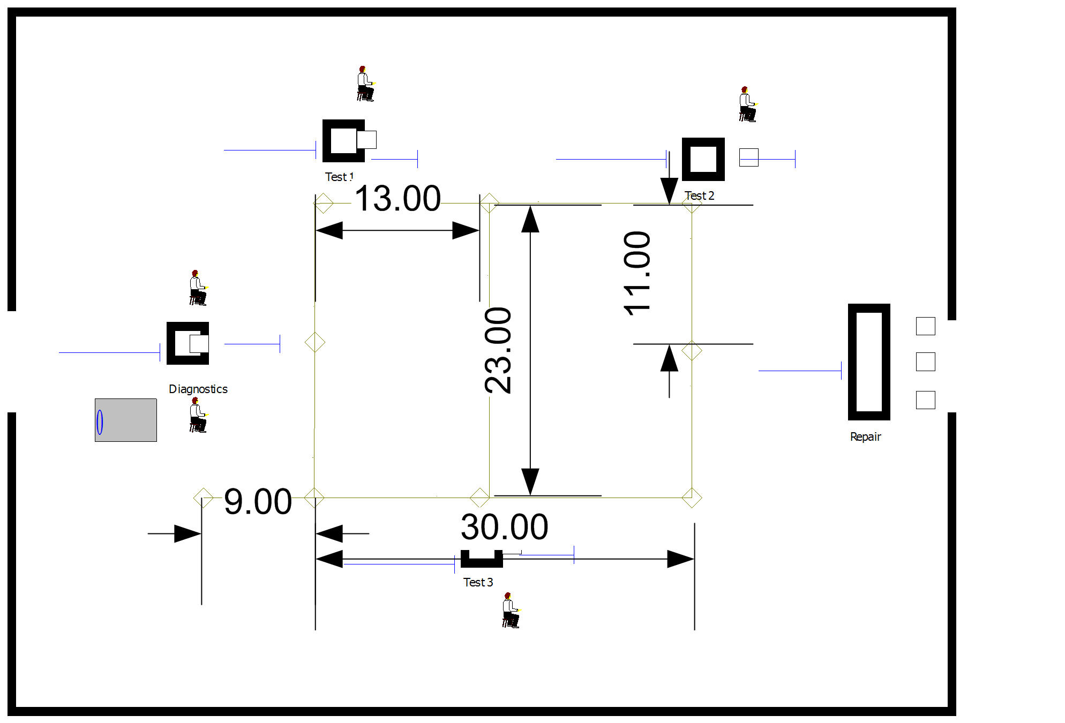
Figure 7.52: Proposed system layout
There is only 1 AGV in this system. It is 1 meter in length and moves at a velocity of 30 meters per minute. Its home base is at the dead end of the 9 meter spur. Since there will be only one AGV all links are bidirectional. The design associates the stations with the nearest intersection on the path network.
- Simulate the system for 10 replications of 4160 hours. Estimate the chance that the contract specifications are met and the average system time of the jobs. In addition, assess the queuing for and the utilization of the AGV.
- Consider the possibility of having a 2 AGV system. What changes to your design do you recommend? Be specific enough that you could simulate your design.

Steps to build model:

Use the NETWORKLINK module to add the links. Since we only have 1 transporter our definition of zones can be very simplistic.

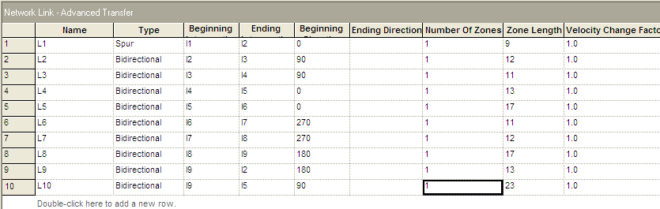

Add the links to the NETWORK module.

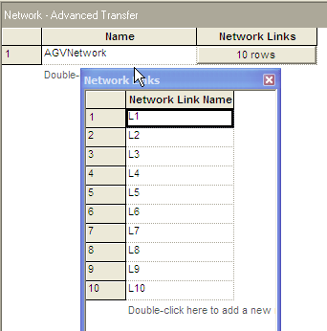

Define the TRANSPORTER

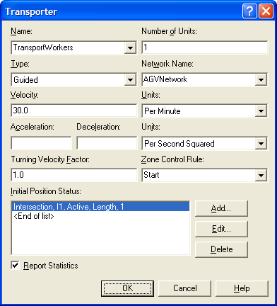

Use the STATION module to associate the following intersections with the corresponding stations:

- I3 with Diagnostics
- I4 with Test Station 1
- I6 with Test Station 2
- I7 with Repair
- I9 with Test Station 3

Use the Network Link tool from the Transfer Animation toolbar to layout the network for the animation.

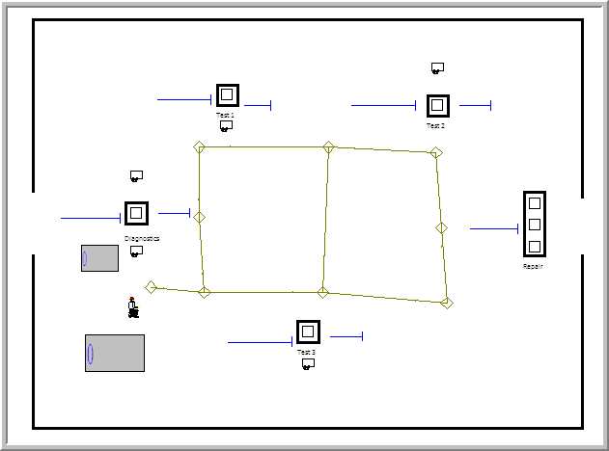

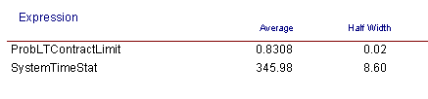

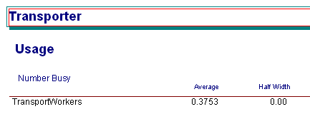

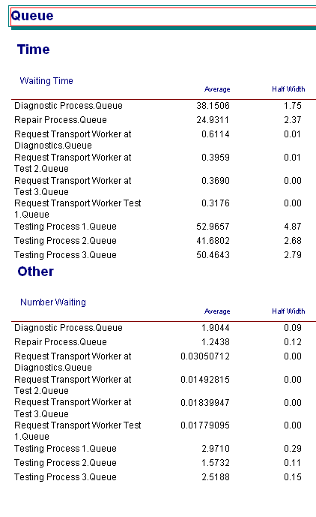
b) Increase the number of units for the transporter.

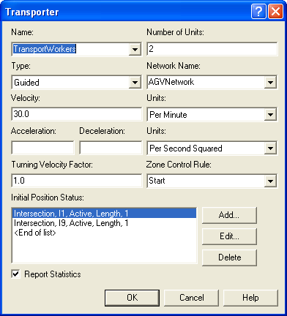

Make travel direction uni-directional to avoid deadlock

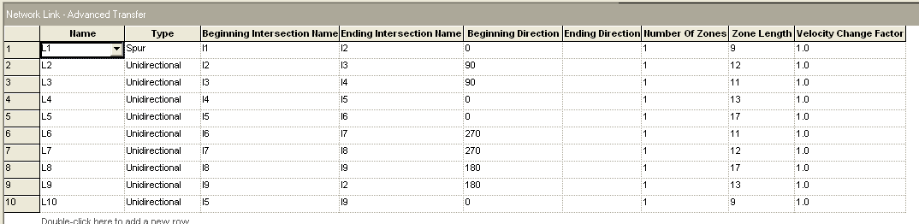
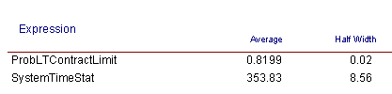

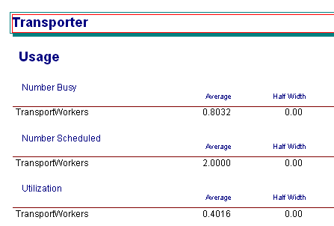

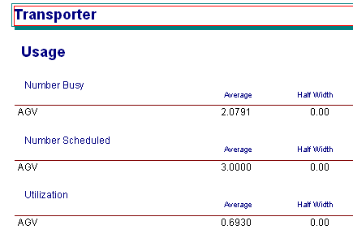

Exercise 7.15 (This problem is based on an example on page 381 of (Pegden, Shannon, and Sadowski 1995). Used with permission). Reconsider Exercise 7.14 with the use of AGVs. There are now 3 AGVs that travel at a speed of 100 feet per minute to transport the parts within the system.
To avoid deadlock situations the guided path network has been designed for one way travel. In addition, to prevent an idle vehicle from blocking vehicles performing transports, a staging area (Intersection 12)has been placed on the guided path network. Whenever a vehicle completes a transport, a check should be made of the number of requests pending for the transporters. If there are no requests pending, the AGV should be sent to the staging area. If there are multiple vehicles idle, they should wait on Link 11. Link 15 is a spur from intersection 6 to intersection 11. The stations for the operation on the parts should be assigned to the intersections as shown in the figure. The links should all be divided into zones of 10 feet each. The initial position of the vehicles should be along Link 11. Each vehicle is 10 feet in length or 1 zone. The release at start form of zone control should be used.
The guided path network for the AGVs is given in Figure 7.53:
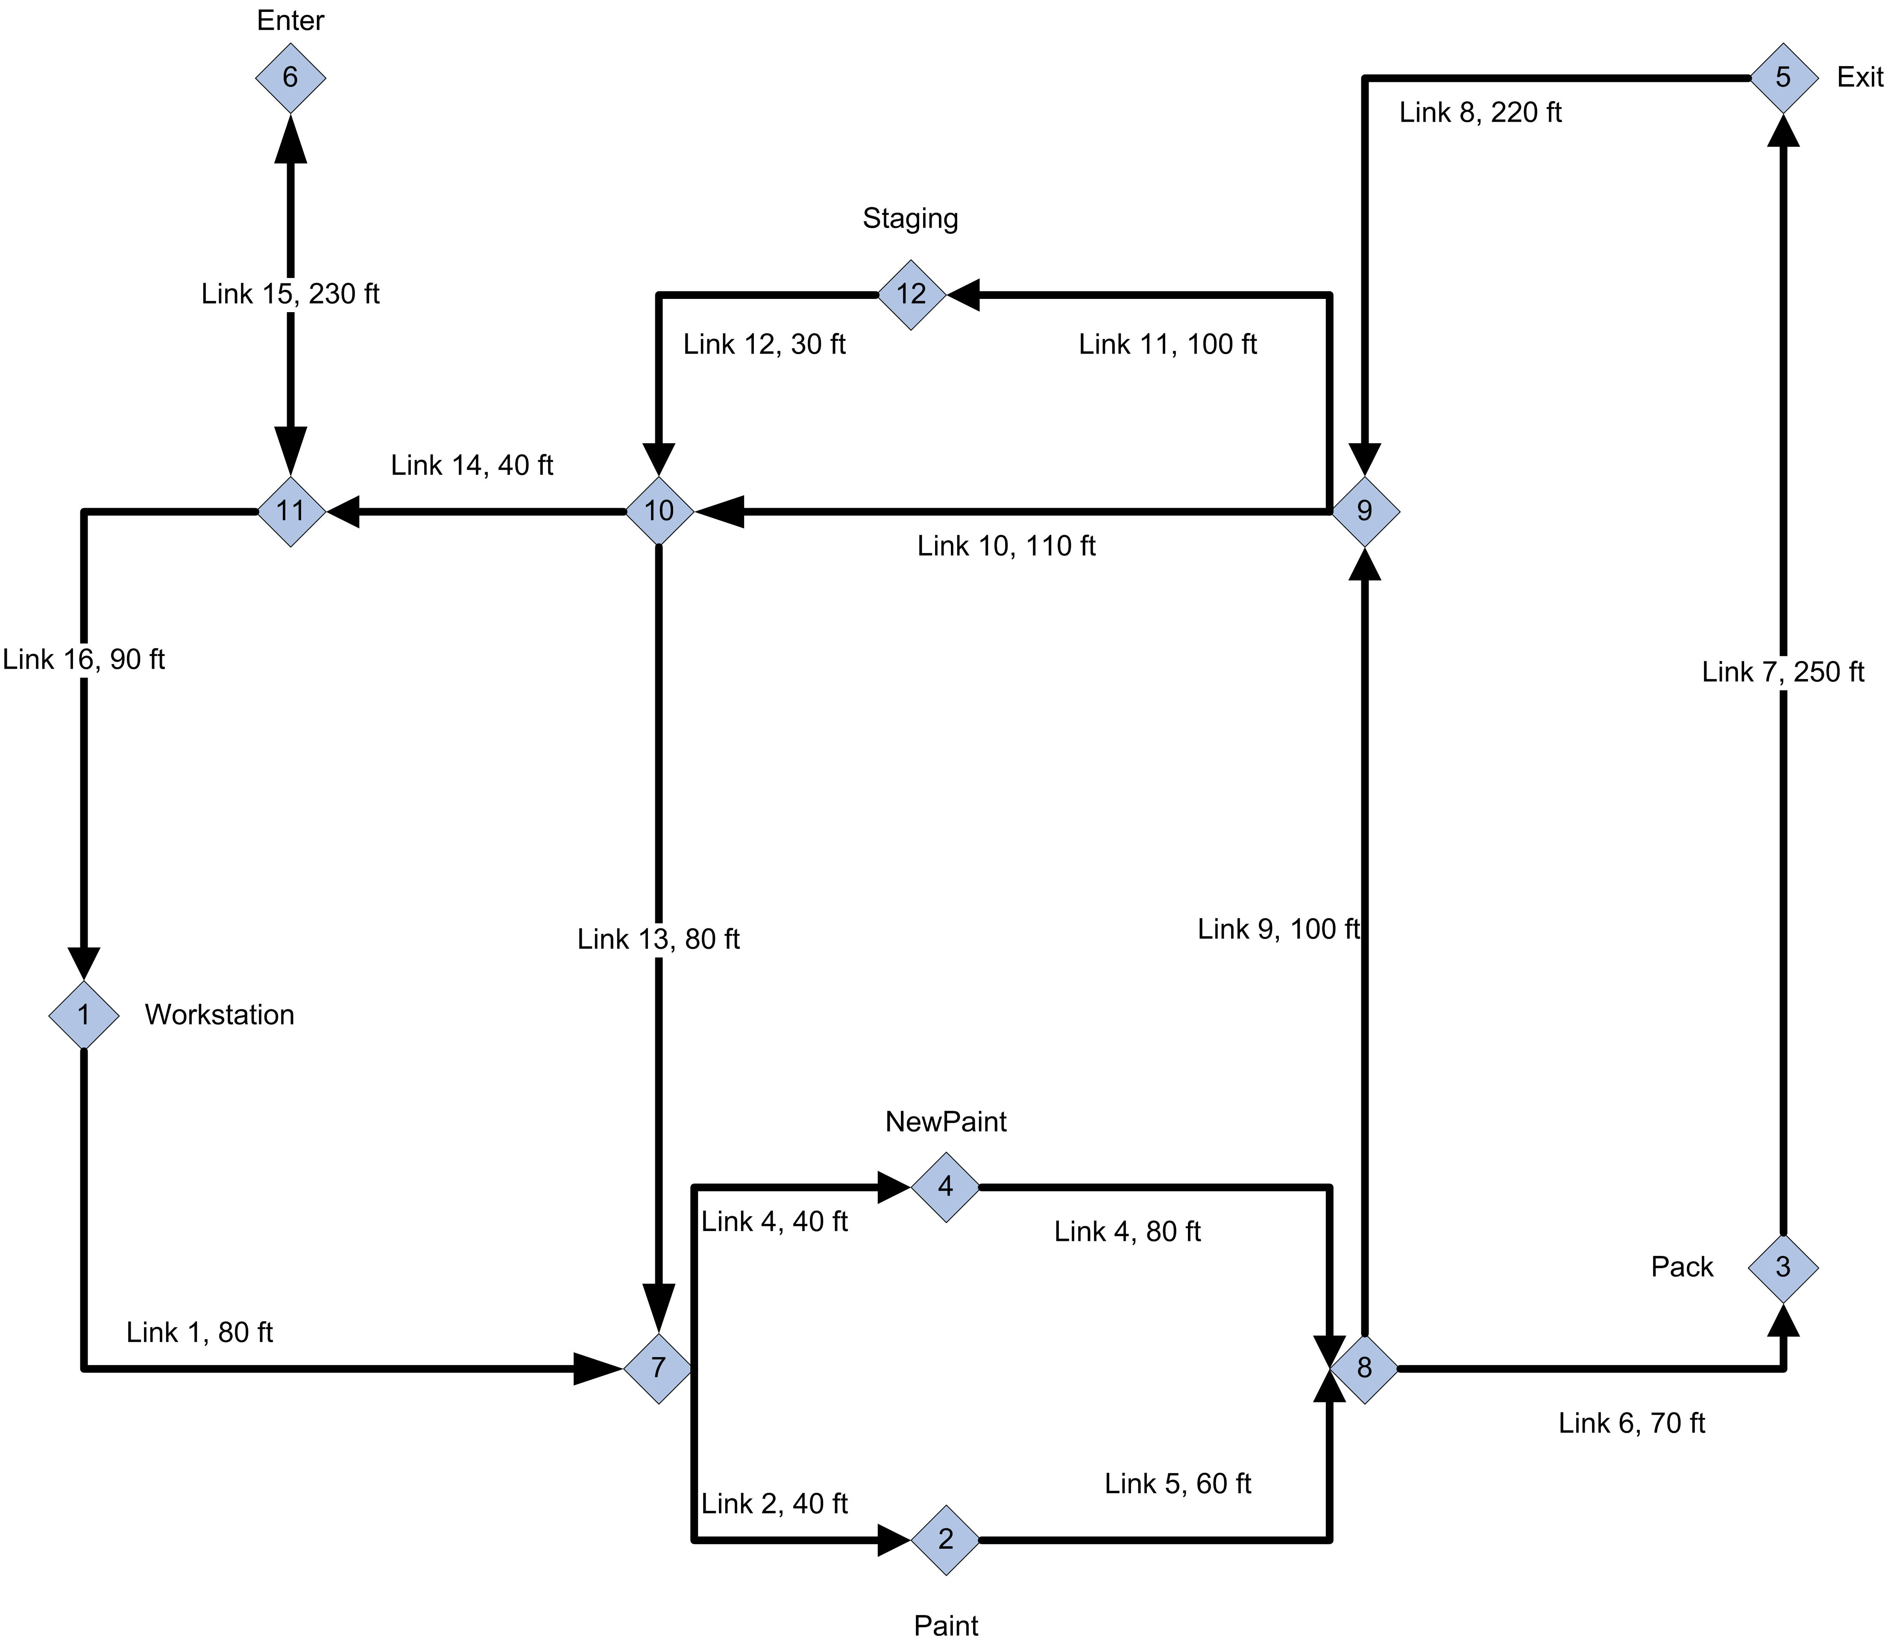
Figure 7.53: AGV system layout
Analyze this system to determine any potential bottleneck operations. Report on the average flow times of the parts as a whole and individually. Also obtain statistics representing the average number of parts waiting for allocation of a transporter and the number of busy transporters. Run the model for 600,000 minutes with a 50,000 minute warm up period. Develop an animation for this system that illustrates the transport and queuing within the system.
The first step is to define the network links and the network.
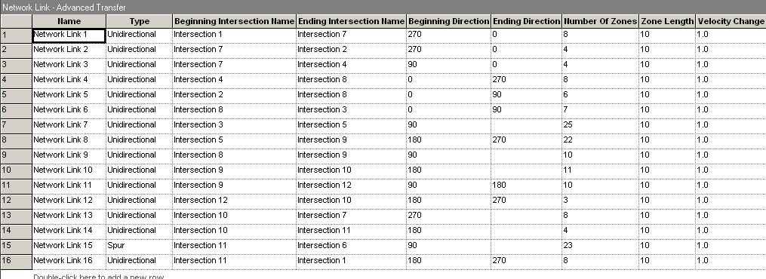

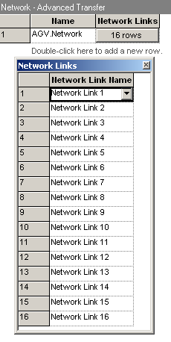

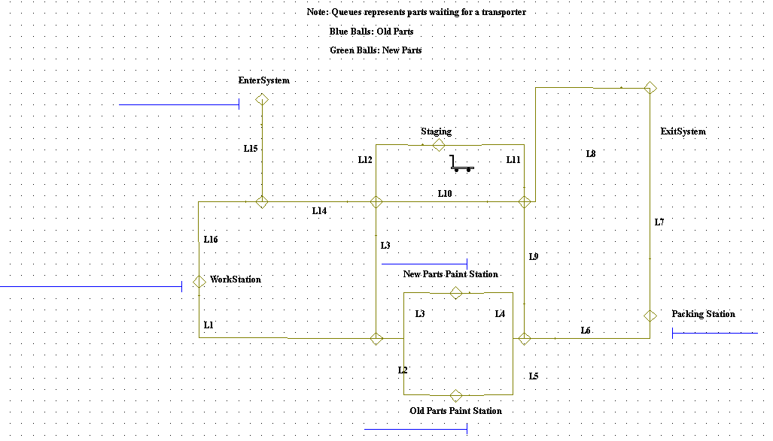

Then redefine the transporter to be a guided path transporter.

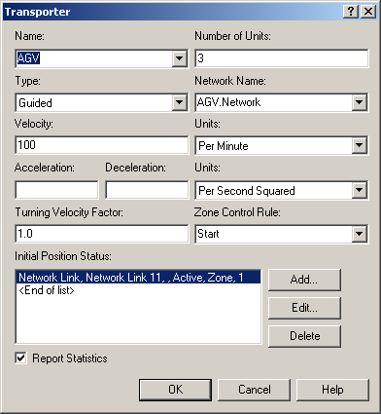

The parts enter the system and are assigned their attributes prior to requesting an AGV for transport.
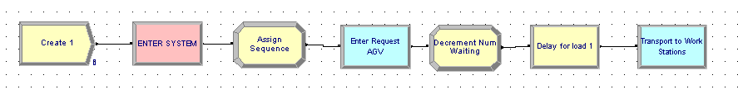

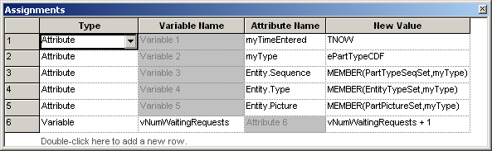

The four Stations were modeled as generic stations with the ‘ENTER’ module. Station type was SET and an attribute myStation was used to index a specific number into the set according to the station the part visited. When the part with a transporter enters the station, there is a check whether or not there are waiting parts, if so the transporter is freed and the part enters the station. If no requests are waiting, then the SEPARATE module duplicates the part with the original going into the station and the duplicate maintaining control of the transporter to allow a transport to the staging area.

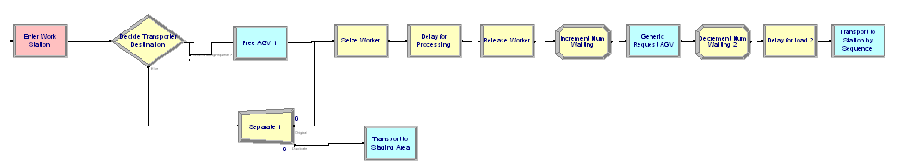

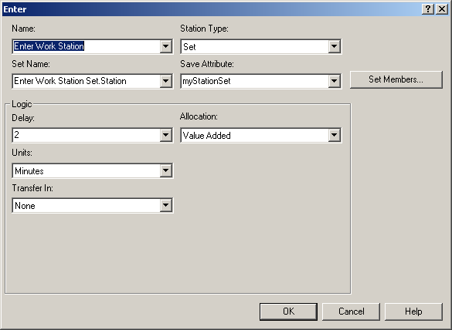

A variable was used (vNumWaitingRequest) is used to track the number of requests waiting for the transporters. It is incremented prior to a request being made and decremented after the request is handled. This allows a simpler expression for the DECIDE module.

